

American International University-Bangladesh (AIUB)  
 **Department of Computer Science  
 Faculty of Science &Technology (FST) Summer 18_19**

**<** Residential water supply management with IOT-based tank system **>**

A software Engineering Sec: **< D >** project submitted

By

*HASAN,TANJIMUL(17-33430-1)*

*MD.MINHAJUL ISLAM (17-34048-1)*

*IFTIKHARUL FARIDEE NUR (17-34013-1)*

*BHUYAN,AL-NOOR FAHIM (17-33831-1)*

The project will be Evaluated for the following Course Outcomes

|  |  |
| --- | --- |
| CO3: Choose appropriate software engineering model in a software development environment | Total Marks |
|  |
| Content Knowledge [5Marks] |  |
| Argumentation [5Marks] |  |
| Evidence of Argumentation [5Marks] |  |
| Completeness, Spelling, grammar and Organization of the Answer [5Marks] |  |
|  | |
| CO4: Explain the roles and their responsibilities in the software project management activities | Total Marks |
|  |
| Project Background Analysis [5Marks] |  |
| Project Role identification [5Marks] |  |
| Responsibility Description [5Marks] |  |
| Completeness, Spelling, grammar and Organization of the Answer [5Marks] |  |

Corporate Personnel Name: M. Fazlul Karim

Company: WellDev bangladesh

Designation: Lead Engineer

Contact Details:

Sign:

**Project Name:** Residential water supply management with IOT-based tank system.

**Problem Statement:** While in this era of smart technologies Bangladesh is forwarding keeping pace with other countries, many sectors of our day to day life is till now out of the scope of ICT, especially those which can be of great value with sensor-based embedded technology that is popularly referred as IOT (Internet of Things). One of these possible sectors is residential water supply management.

**Existing Solution:** At present in most of the houses with tank facilities the task of water supply is managed manually, i.e. some person has to check the availability of water in the tank and switch the power button of the pump on/ off accordingly. This practice introduces some problems such as-

* Direct involvement of persons with on/ off system.
* Keeping track of availability of water and checking whether the tank has been filled up during the operation period of the motor certainly wastes valuable labour hours.
* In most of the cases some water essentially overflows.
* There is no fruitful backup/reservation system of water for emergency cases such as unexpected power failure for a significant amount of time.
* Unsynchronized usage of motors surely rises the electric bill in some extent unnecessarily.

**Block Diagram of Existing Solution:**

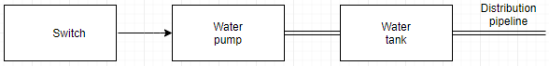

**Proposed Solution:** Our System will be sensor-based and automated which will resolve the existing problems in following ways-

* No direct involvement of human, since the sensor will sense the current water level and turn the switch of the motor on/ off automatically.
* Setting human free from direct involvement will save valuable labour hours.
* System controlled mechanism will prohibit water to overflow.
* More than one tank will be arranged which will work concurrently (not simultaneously). This will ensure the reservation of water for emergency cases. To be clear, let assume two tanks A and B. At first both of the tanks will remain full. But only one tank- say tank A- will be put in use by the system. When the water level of tank A will coincide with the predefined level (say 30% of total) the system will close its (tank A) channel and open that of tank B. At that time tank A will go to refilling mode. Eventually, tank A will be filled up and go in reserved mode. And when water level of tank B will coincide with the predefined level, the described cycle will be recurred in the context of B. This will happen turn by turn. It should be noted that, since the reservation of water in a particular tank for a long period of time (if luckily emergency case does not occur) will cause the water to be impure/ quality-less , our system will use both/ all of the tanks concurrently as described above.
* Synchronized usage of pump will keep the electric bill reasonable.
* Finally there will be client program/ apps of two types able to run in a mobile device. One for the authority (which will have the features of informing and being controlled by the authority). Another for the users –say dwellers of different flats- (which will have only the informing features).

**Block Diagram of Proposed Solution:**

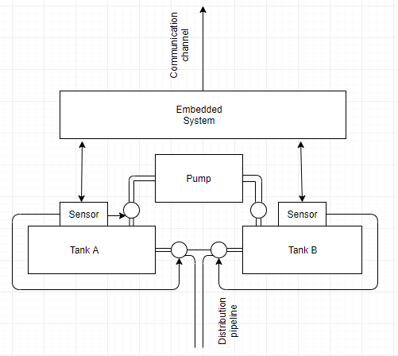

**Features** :

**Login**: - User will login to the system.

**Sensor**: - Sensor can monitor water level. When the water level decrease less than 10% then it will open the bulb of another tank so that water can distribute in a systematic way.

**Tank A**:It is the system actor when the water level of tank B less than 30% then tank B will active.

**Tank B**:It is the system actor when the water level of tank A less than 30% then tank B will active.

**Does the project have a clear target market or audience?**

Each experienced businessman and entrepreneur can prove that one of the most critical elements in the strategic management of any project is an analysis of the target audience. Because the right concentration on customers can enhance all our efforts to make something worthy and unique. Yes, our project has a clear target market for residential water supply management system where user can easily find the update of water level through software. So, there is no issue of water overflow. It will also reduce the electric bill.

**Is the project’s purpose and basic functionality easily understood?**

Yes, the project’s purpose and basic functionality are easily understood by the user. This project provides a clear idea to them why this is necessary for them. We also try to inform them about our project’s purpose and our basic functionality of our developing software. As this is an IoT based project many smart phone users get benefitted from this project who need to know about the water level and supply of their house at any time by just using a simple smart phone application. Our project purpose is to develop that type of software system that gives a better service for a person who need it for smart use.

**Scenario of Use Cases**:

Authority can switch on/off. Getting information is dependent on switch on/off. Sensor informs communicator and also informs controller. Controller opens exit of tank B, closes exit of tank A, opens entrance of tank A, starts the pump, stops the pump and stops entrance of tank A.

**Use Case diagram**:

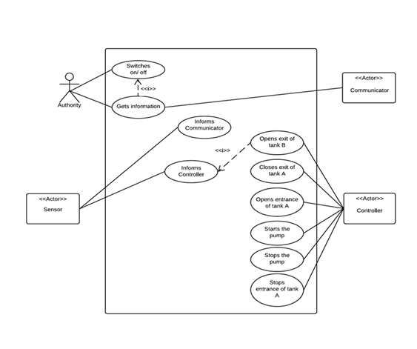

**Scenario of Classes**:

One authority can communicate with One communicator at a time. Two

Or more sensor senses the water level and passes message to authority through communicator. Sensor also sends message to controller. The controller controls the bulb (Open and close the bulb according to the water level of tank A, tank B) .

**Class Diagram**:

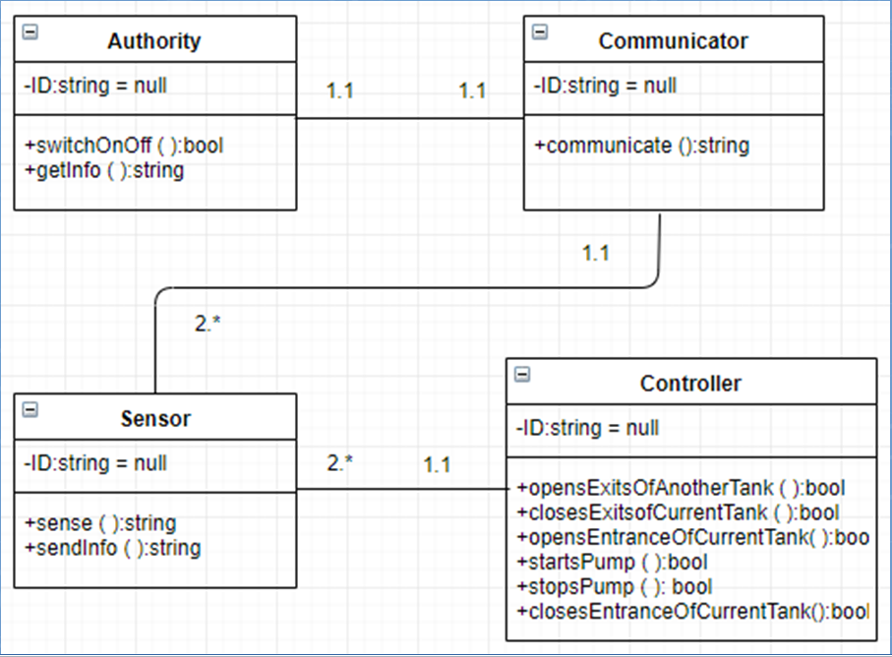

**Scenario of Activity Diagram**: Authority can switch on. Sensor can sense the current status and passes data to Communicator. Communicator simultaneously passes data to authority and passes data to communicator. Then controller checks the water level. If the water level is less than 10% than sensor remains idle. If not then opens the exit of tank B. In that time closes the exit of tank A. Also opens the entrance of tank A.

**Activity Diagram**:

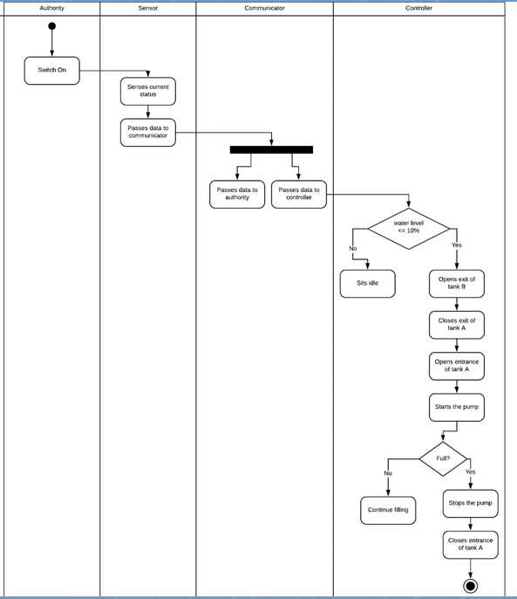

Assessing the project information, which software engineering process model are you going to follow in order to develop the software? Give sufficient arguments in support of your model selection.

The software that we are going to develop will have very few but effective functionalities. It should be designed and coded in such a way that it fulfills its goal. A simple mistake will bring a great problem. Assessing the project information we are going to use an Agile Method which is known as **SCRUM.** Since it is a small project and the group consists few number of people which is totally accepted in SCRUM methodology, we’ve decided to use this Agile method for our Project.

Scrum is an iterative and incremental agile software development framework for managing product development. It defines a flexible, holistic product development strategy where a development team works as a unit to reach a common goal. This method enables teams to self-organize by encouraging physical co-location or close online collaboration of all team members, as well as daily face-to-face communication among all team members and disciplines involved. We are going to use SCRUM life cycle to develop our software. Here is a short description of SCRUM life Cycle and how it works:

The flow of Scrum life cycle consists of the following parts:

1. Product Backlog
2. Sprint Planning
3. Sprint Backlog
4. Sprint
5. Daily Scrum
6. Sprint Review

**Product Backlog**

The product backlog is a list of things to be done for a project. It is also known as a wish list since the product owner would ideally like all items in the list to be worked on. The product backlog is similar to listing out requirements and specifications for a project. The list is prioritized and broken out into tickets with details that could be technical or in the form of user stories. The product backlog changes over the course of the project as new requirements are added, modified or deleted. The product owner is responsible for keeping the product backlog current.

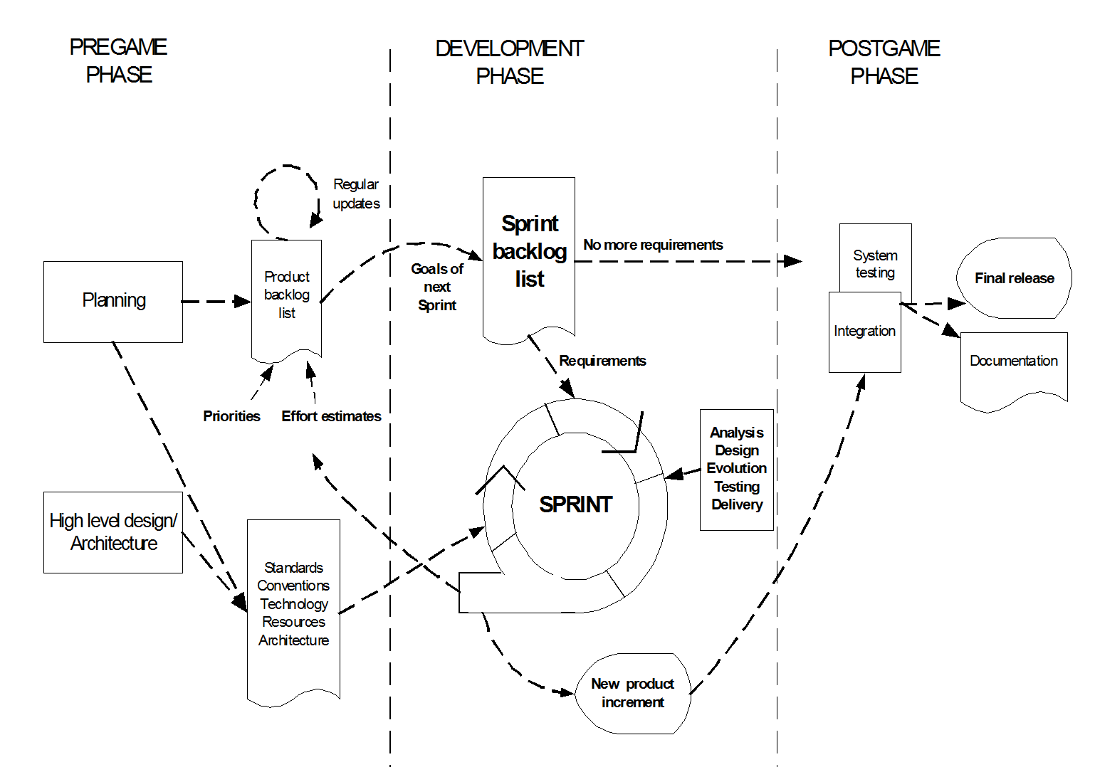

**Sprint Planning**

Sprint planning is a meeting that is held between the Scrum Master, Product Owner and the rest of the Agile team. It is usually timeboxed to an hour and the team members meet to discuss and plan the tickets that will be worked on from the product backlog. The acceptance criteria are discussed and effort needed to perform the work is estimated. The top priority tickets are usually planned first and if there is room for lesser priority tickets, they are added after. What the team takes on is dependent on the length of the sprint, the team’s capacity, and velocity. The final tickets that are agreed on will go into the sprint backlog.

**Sprint Backlog**

The list of tasks/tickets that have been agreed on by the Scrum team to be completed within a sprint is the sprint backlog. These define the size of the sprint backlog based on the commitments from the Scrum team. During a sprint, the backlog is tracked and updated regularly with any new information pertaining to the work being performed. Sometimes, too much or too little work can be planned for a sprint backlog. When this happens, tickets either need to be removed or added to the backlog to balance the sprint.

**Sprints**

A sprint is a timeboxed period of time in which work needs to be completed and ready for review. In Scrum, the length of a sprint is usually based on the way a team works and how quickly they need to provide working pieces of software. Sprints can be as short as one week and as long as four weeks. The Scrum Master usually determines the length of a sprint with agreements from the team. Once the length is set, it should be continuous for all future sprints.

**Daily Scrum**

Daily scrum or daily stand-up is a fifteen-minute time-boxed meeting. This meeting happens every day at the same time and location. This is an opportunity for the development team to discuss what they accomplished the day before, what they will be working on for the day and what obstacles are impeding their progress. The Scrum Master is usually the facilitator. The meeting is meant for all team members to share their input on the sprint and get a clear understanding on what work was already completed, what issues need resolving and what is left to do. This will give good insight into the progress of the sprint and give an early indicator on if the commitments and sprint goal are being met.

**Sprint Review**

At the end of each sprint, the team is responsible for providing a working piece of software that is potentially shippable. Because of this, sprint review meetings are usually held for the team to demonstrate what they completed during the sprint and to get feedback from the product owner and other stakeholders. The final result is weighed against the initial sprint goal and the team can use this time to provide their suggestions on what was accomplished. Sprint reviews should not be extremely long and should fall anywhere between one to two hours maximum.

->Give sufficient arguments in support of your model selection.

A key principle of Scrum is the dual recognition that customers will change their minds about what they want or need (requirements volatility) and that there will. Scrum adopts an evidence-based empirical approach accepting that the problem cannot be fully understood or defined up front, and instead focusing on how to maximize the team’s ability to deliver quickly, to respond to emerging requirements, and to adapt to evolving technologies and changes in market conditions.

Main features of Scrum:

* a living backlog of prioritized work to be done
* completion of a fixed set of backlog items in a series of short iterations or sprints
* a brief daily meeting (“a scrum”) for explaining the progress, describing an upcoming work and possible obstacles
* a brief planning session in which the backlog items for the sprint will be defined
* a brief heartbeat retrospective when all team members reflect about the past sprint

Scrum is facilitated by a scrum master, whose primary job is to remove impediments to the ability of the team to deliver the sprint goal. The scrum master is not the leader of the team (as they are self-organizing) but acts as a productivity buffer between the team and any destabilizing influences.  
This method encourages verbal communication across all team members and across all disciplines that are involved in the project.

Scrum is more time boxed and planned. Scrum is best suited when the cost of delay is high and deadlines should meet a minimal delay. Scrum takes its place among flexible methodologies that are appropriate for long-run development with frequent changes to requirements. In other words, it is suitable for projects that demand over 300 hours of development. The Scrum model adopts flexible disciplines which are open to last-minute changes. Teamwork, inspection, and transparency are key factors in the Scrum method.

Pros

* Decision making lies in the hands of the team
* Business requirement document is considered insignificant
* Lightly controlled method empathizing with constant updating

**SCRUM estimation:**

In Scrum Projects, Estimation is done by the entire team during Sprint Planning Meeting. The objective of the Estimation would be to consider the User Stories for the Sprint by Priority and by the Ability of the team to deliver during the Time Box of the Sprint.

Product Owner ensures that the prioritized User Stories are clear, can be subjected to estimation, and they are brought to the beginning of the Product Backlog. As the Scrum Team in total is responsible for the delivery of the product increment, care would be taken to select the User Stories for the Sprint based on the size of the Product Increment and the effort required for the same. The size of the Product Increment is estimated in terms of User Story Points. Once the size is determined, the effort is estimated by means of the past data, i.e., effort per User Story Point called Productivity. For our product we will use planning poker technique.

**Planning Poker Technique:**

In Planning Poker Estimation Technique, estimates for the User Stories are derived by playing planning poker. The entire Scrum Team is involved and it results in quick but reliable estimates.

Planning Poker is played with a deck of cards. As Fibonacci sequence is used, the cards have numbers - 1, 2, 3, 5, 8, 13, 21, 34, etc. These numbers represent the Story Points. Each estimator has a deck of cards. The numbers on the cards should be large enough to be visible to all the team members, when one of the team members holds up a card.

**Benefits of Planning Poker Estimation:**

Planning poker combines three methods of estimation -

**Expert Opinion** : In an Expert Opinion based Estimation approach, an expert is asked how long something will take or how big it will be. The expert provides an estimate relying on his or her experience or intuition or gut feel.

Expert Opinion Estimation usually doesn’t take much time and is more accurate compared to some of the analytical methods.

**Analogy** : Analogy Estimation uses comparison of User Stories. The User Story under Estimation is compared with similar User Stories implemented earlier. This results in accurate results as the estimation is based on proven data.

**Disaggregation** : Disaggregation Estimation is done by splitting a User Story into smaller, easier-to-estimate User Stories. The user stories to be included in a Sprint are normally in the range of two to five days to develop. Hence, the User Stories that possibly take longer duration need to be split into smaller Use Cases. This approach also ensures that there would be many stories that are comparable.

**Scheduling in scrum:**

Scrum schedule must be set up early.  The Scrum Master has to work with leadership and account for team make-up.  Figuring out everything ahead of time and then set the Scrum schedule that will be in agreement with the team have to meet. Sprints within Scrum have a defined start and a defined end.  With a Scrum schedule, One can manage the plan to draw out the most value possible. The ideal Scrum schedule is one that accommodates for many variables.  The variables allow the teams to be faithful to the cadence.  Scrum revolves around the Sprint’s cadence, and making sure that the cadence is constant is most important. Changes to the Sprint cadence due to unaccounted for conflicts should be avoided.  Rescheduling a Scrum event is never ideal. Keeping the cadence constant allows the Scrum team to remain within the defined process and focus more on value-based delivery.  People get into the routine, know what they have to do to prepare for meetings, etc.  Once the process is consistent, they can lean on that and focus on delivery.  Consistency is key. Consistency is not just about the length of time for the Sprint; it is for all of the Scrum Events.  The events including Sprint Planning, Retrospective, etc. need to happen at the same time during every Sprint.  The same time means that it has to be on the same day, at the same hour, and with the same time box associated with it.

Having the consistency allows the whole Scrum team to relax.  Team members do not have to worry about the minor details of the meeting such as the format, the location, etc.  The focus can be entirely on the delivery at the Sprint level.

**Risk Management of SCRUM:**

In software development risk is one of the main concerns.70% of the software fails to be fully completed as they possess high amount of risk. It happens because many type of risk was overlooked which caused the fail of a software in future. SCRUM effectively deals with the risks during the development of a project. In a word Scrum is all about risk management. Scrum has a very good way of controlling risk in a number of ways. Let’s talk about the risks and how SCRUM deals with it:

**Risk Management consists of five steps:**

1. Risk identification: Using various techniques to identify all potential risks

2. Risk assessment: Evaluating and estimating the identified risks

3. Risk prioritization – Prioritizing Risk to be included for specific action in the Prioritized Product Backlog

4. Risk mitigation: Developing an appropriate strategy to deal with the risk

5. Risk communication: Communicating the findings from the first four steps to the appropriate stakeholders and determining their perception regarding the uncertain events.

**Risk Identification**

The Scrum Team members should attempt to identify all risks that could potentially impact the project. Only by looking at the project from different perspectives, using a variety of techniques, can they do this job thoroughly. Risk Identification is done throughout the project and Identified Risks become inputs to several Scrum processes including Create Prioritized Product Backlog, Groom Prioritized Product Backlog, and Demonstrate and Validate Sprint.

**Risk Assessment**

The assessment of risk helps in understanding the potential impact of a risk, how likely it is to occur, and when the risk could materialize. The overall effect on business value should be estimated, and if that impact is significant enough to outweigh the business justification, a decision must be made whether to continue the project. The assessment of risks is done with regard to probability, proximity, and impact. Probability of risks refers to the likelihood of the risk occurring, whereas proximity refers to when the risk might occur. Impact refers to the probable effect of the risks on the project or the organization. To estimate the probability of a risk various techniques may be used, including Probability Trees, Pareto Analysis, and a Probability and Impact Matrix. In addition to probability, risk assessment also evaluates the potential net effect of risks on the project or organization. These effects can be estimated using techniques such as Risk Models and Expected Monetary Value.

**Risk Prioritization**

Scrum allows for quick identification and assessment of risks. Identified Risks are taken into account when creating a Prioritized Product Backlog during Create Prioritized Product Backlog process, or when we update the Prioritized Product Backlog during Groom Prioritized Product Backlog process—so a Prioritized Product Backlog could also be referred to as a Risk Adjusted Prioritized Product Backlog. The risks could be identified and assessed based on any of the Risk Identification and Risk Assessment techniques mentioned earlier.

**Risk Mitigation**

The response to each risk will depend on the probability and impact of the risk. However, the iterative nature of Scrum with its rapid turnaround time and feedback cycles allows for early detection of failures; therefore, practically speaking, it has a natural mitigation feature built in. Risk can be mitigated by implementing a number of responses. In most situations, responses are proactive or reactive. In the case of a risk, a plan B may be formulated, which can be used as a fallback in case the risk materializes – such a plan B is a reactive response. Sometimes risks are accepted and are an example of a risk response which is neither proactive nor reactive. Risks are accepted because of various reasons, as in a situation where the probability or impact of the risk is too low for a response. Acceptance can also be the case in a situation where the apprehension of secondary risks may deter the product owner from taking any action. The effort made by the Product Owner to reduce the probability or impact—or both—of the risk is an example of a proactive response to mitigating risks.

**Risk Communication**

Because stakeholders have an interest in the project, it is important to communicate with them regarding risks. Information provided to stakeholders related to risk should include potential impact and the plans for responding to each risk. This communication is on-going and should occur in parallel with the four sequential steps discussed thus far—risk identification, assessment, prioritization and mitigation. The Scrum Team may also discuss specific risks related to their Tasks with the Scrum Master during Daily Standup Meetings. The Product Owner is responsible for the prioritization of risks and for communicating the prioritized list to the Scrum Team. An important tool which can be used for communicating information related to risks is the Risk Burndown Chart.

**Effort Estimation**

Line of code(LOC)

|  |  |
| --- | --- |
| User Interface | 1000 |
| Database Connection | 1400 |
| Logical Expression | 600 |
| Build Function | 1500 |
| TOTAL | 4500 |

Our Project is an organic type of project. So the values will be as follows:-

Project Complexity, P = 1.12

SLOC dependent Coefficient, T = 0.35

Coefficient<Effort Factor> = 3.0

SLOC = 4000

Effort = PM = Coefficient *(SLOC/1000)^P

=3.0*(4500/1000)^1.12

=16.17

Development time = DM =2.50*(PM)^T

=2.50*(16.17)^0.35

=6.62

Required number of people = ST = PM/DM

= 16.17/6.62

=2.4

=2.4 People

**Other costs** :

(1) RASBERRY PI 3 MODEL B+ FULL SET = 5,000

(2) Water Level sensor Depth of Detection water sensor for Arduino =250*2=500

(3)ESP8266 ESP –WIFI WIRELESS TRANSCEIVER

**Scheduling:**

|  |  |  |  |  |  |  |  |  |  |  |  |  |  |  |  |  |  |  |  |  |  |  |  |  |
| --- | --- | --- | --- | --- | --- | --- | --- | --- | --- | --- | --- | --- | --- | --- | --- | --- | --- | --- | --- | --- | --- | --- | --- | --- |
| Work tasks | Week 1 | | | | Week 2 | | | | Week 3 | | | | Week 4 | | | | Week 5 | | | | Week 6 | | | |
| * 1. Identify need and benefits   Identify need and project constraints  Establish product statement  Milestone: product statement defined   * 1. Define software components   Input functions  Output functions  Review components with team  Milestone: components defined   * 1. Research availability of existing software   Research on existing product  Find reusable components  Milestone: Reusable components identified   * 1. Define technical feasibility   2. Make quick estimation of size   3. Create scope definition   Review scope with team  Milestone: Scope document complete   1. Design UML   Milestone: Review UML diagrams   * 1. Define database elements   Identify database info    Milestone: Database defined   * 1. Build the code   Build all the classes  Establish database connectivity  Review code  Milestone: complete coding   * 1. Making GUI of the software   Review GUI  Milestone: Complete GUI   * 1. Software testing   Unit testing  Regression testing  Debugging  Milestone: testing and debugging completed   * 1. Verification   Validation  Review the software  Milestone: Complete software |  |  |  |  |  |  |  |  |  |  |  |  |  |  |  |  |  |  |  |  |  |  |  |  |

**Project Role Identification**

* + How effectively the student identifies all the roles in the project management activities in software development?

Project management is the application of processes, methods, skills, knowledge and experience to achieve specific project objectives according to the project acceptance criteria within agreed parameters. Project management has final deliverables that are constrained to a finite timescale and budget. A project management consists of some very important roles. There are 6 of them.

1.Project Manger

2.Project Team

3.Steering Committee

4.project Client

5.Project Management Office

6.Resource Manger

While using SCRUM for our project we get to be familiarized with these roles in a very effective way. In scrum method project manager is known a scrum Master. The project team is known as Scrum team. Customer is the project client. Management is the project management and also controls the resource.

**Responsibility Description**

* + How effectively the student describes the responsibilities of the role in the software development?

Scrum roles maintains project management roles in a very good way.

**Project Manager:**

Scrum master takes the role as project manager. Scrum master is the main responsible person for the project. He decides everything about how the project will be done. He recruits other roles. All the Scrum meeting are arranged by him. From the dawn to delivery of the project he leads the project.

Project Team:

Scrum team takes the role as project team. The team does all the activities of the project.Like Coding, Testing, Setting how one iteration will be done. Their role is to successfully perform the project tasks and activities that have been assigned to them, keeping the Project Managers apprised of the progress, as well as any roadblocks that may arise during the project execution.

**Project Client:**

The customer is the project client. The whole project is in development because the customer wanted it.

**Steering Committee:**

There is no Steering Committee. The management Controls all of the thing of Steering Committee.

**Project Management Office:**

The management office controls the whole project. They can cancel out the project. They have the full authority on the project as they recruits everything and manages everything.

**Resource Manager:**

Scrum master works as a resource manager. The provides all the resources the team needed.